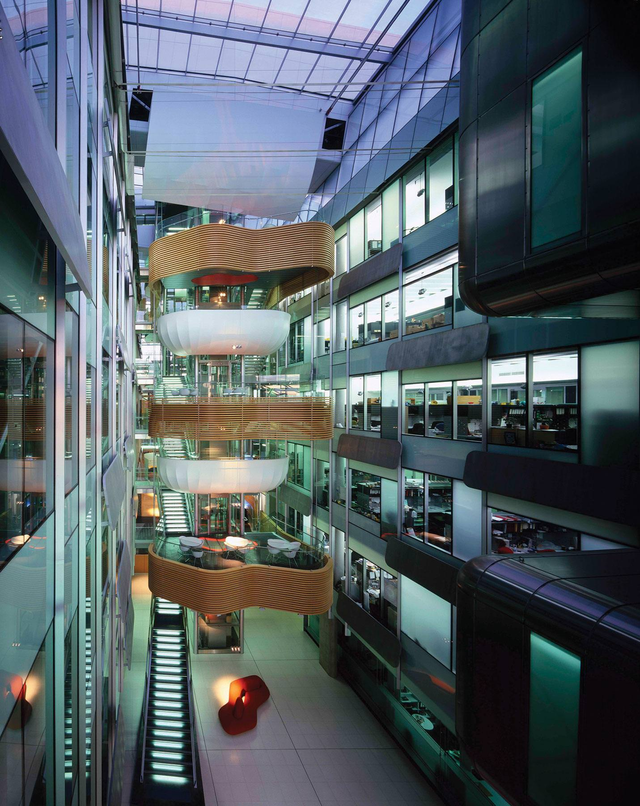
The Bio21 Molecular Science and Biotechnology Institute

Where sciences, technologies and sectors meet, turning joint endeavour into new insights, treatments and products.

The Bio21 Molecular Science and Biotechnology Institute (Bio21) in Parkville is one of Australia’s largest biotechnology research centres, housing state-of-the-art equipment, scientists, students, university departments and industry groups. Bio21 has become the lynchpin of diverse research partnerships and industry activity at every scale, as the R&D headquarters of Australia’s biggest biopharmaceutical company CSL, and the home of a successful biomedical business incubator. Bio21 harnesses molecular science, expert capability and a powerful biotechnology toolkit to solve the pressing health, environmental and agricultural challenges of our time.

Bio21 is a multidisciplinary hub that brings the top minds in academia and industry together with core platform technology and supportive infrastructure. As one of the University of Melbourne’s flagship R&D facilities and first cross-faculty institute, Bio21 has gained global recognition for excellence in fundamental research, building productive partnerships, and setting up commercialisation pathways through interactions with leading biotechnology companies for new therapies and biotechnology.
The Bio21 Institute began nearly two decades ago with the idea that groundbreaking scientific discoveries and inventions often happen through the interaction of distinct fields, such as the collision of life sciences, physical and chemical sciences, computing, genomics, molecular biology and engineering. Rather than working in the academic silos of the past, Bio21 enabled the University of Melbourne’s STEM departments to collaborate and co-create with other leading research entities.
Today Bio21 hosts ~800 personnel and four buildings with the 6-storey David Penington Building looking over Flemington Road in Parkville. It is in walking distance of the other major institutions in the surrounding biomedical and university precincts. Its nationally-significant equipment platforms – representing more than $50m of investment – are heavily used by partnering hospitals and research organisations across the Melbourne Biomedical Precinct. In this way, the broadest array of scientists, developers and technicians from private and public sectors are able to access and use the specialised equipment to gain new knowledge and translate their discoveries.
In early 2020, along with other research centres in the Melbourne Biomedical Precinct, Bio21 drew on its resources (particularly its expertise in structural biology) to grapple with the unprecedented challenge of the novel coronavirus. Leading researchers at the Bio21 Advanced Microscopy Facility, in collaboration with the Peter Doherty Institute and Melbourne Health, used Bio21’s Transmission Electron Microscopes to obtain some of the first images of the isolated and cultured coronavirus outside of China. Bio21 also has powerful tools that enable images of the fine structure of the virus at atomic resolution, which is the first step for structure-based drug discovery of treatments for COVID-19.
Bio21’s beginnings trace back to 2001, when leaders in the University of Melbourne, Melbourne Health, and the Walter and Eliza Hall Institute of Medical Research identified a need for greater recognition and organisation of biotechnology activities in Victoria. These institutions partnered together with the Victorian Government to establish Bio21 Australia Limited, which expanded over subsequent years to become the ‘Bio21 Cluster’, representing more than 21 hospitals and medical research institutes.
One of the first proposals of Bio21 Australia was the creation of a formal institute and new premises that could serve as the heart of the network. The institute would be an experiment with three aims: to create a collaborative space for multidisciplinary research; to strengthen Victoria’s engagement with the biotech industry; and to nurture the best and brightest young Australian scientists.
The Bio21 Institute was officially launched in 2005 by former Victorian Premier Mr Steve Bracks. It was funded by contributions from the University of Melbourne ($50m), Federal Government Department of Health and Ageing ($9.5m), Atlantic Philanthropies ($30m) and the Victorian Government ($15m cash, and $15m valued transfer of land under a 99-year Crown Grant Agreement). It speaks of the ethos of Bio21 that Atlantic Philanthropies, a global grant-making program that has awarded more than $8 billion over 35 years, only funds projects with demonstrably high human returns, featuring strong relationships, big ideas, collaboration and the sharing of knowledge.
In 2018 the Bio21 Institute was expanded with the opening of an additional building named in honour of Nancy Millis to house the University of Melbourne’s Margaret Sheil laboratories, and the new CSL Global Research and Translational Science Hub. The long-term commitment of CSL as an anchor tenant to increase its presence at the Bio21 Institute will help drive collaboration within the Biomedical Precinct and cements the status of the Bio21 Institute as a significant player within the national biomedical innovation landscape.
Bio21’s unique technology attracts outstanding scientists from around the world and enables discovery, knowledge translation and commercialisation. From its inception, Bio21 was designed and built with powerful research instruments in mind; key technologies that simplify processes and amplify progress. The institute’s platform technologies include Magnetic Resonance, Advanced Electron Microscopy, new Protein Characterisation facilities, Systems and Computational Biology facilities, and a major Mass Spectrometry facility for proteomics, metabolomics, lipidomics and analytical chemistry. Many of these are the largest of their kind in Australia and have been supported by government grants, such as the Australian Research Council Linkage Infrastructure, Equipment and Facilities scheme.
Metabolomics capability, one of the most sophisticated technologies housed at Bio21, identifies small molecules in biological materials such as plasma, urine, tissue, plant and microbial extracts. Using high-powered bioinformatics methods, data mining and large-scale analysis in combination with powerful platform technologies, scientists can run crucial tests on new compounds and drugs. The metabolomics capability at Bio21 is part of the federally-funded National Collaborative Research Infrastructure Scheme, and managed through a consortium of national technology platforms under Bioplatforms Australia Pty Ltd.
Bio21 houses these technologies, employs highly-skilled managers to run them, and educates other researchers to use them. The platforms and research infrastructure create rich grounds for discoveries and give Bio21’s collaborators a competitive edge for translating world-leading research into spin-out companies and therapeutic treatments.
By building a STEM pipeline Bio21 is adding to the overall bioscience ecosystem in Australia. Accommodating researchers from academia and industry, including three faculties and eight departments of the University of Melbourne, Bio21 is one of the largest biotechnology research centres in Australia. It currently trains around 380 early career researchers, post-doctorates and Research Higher Degree students.
Students at secondary level are crucial to the STEM pipeline. Bio21 supports the Elizabeth Blackburn School of Science, a branch of University High which enables Year 11 and 12 students who are passionate about science to take their VCE studies out of the classroom and into real labs, with mentors and classes from Bio21 and the University.
Bio21 also runs Year 10 work experience placements; open days; school tours and science experiences; Girls in Science breakfast in Parkville and regional centres, such as Bendigo; and in 2019, a ‘Art and Science of the Periodic Table’ event as part of National Science Week.
Industry partnerships are crucial to how Bio21 works. On the established end of the scale, Bio21’s anchor tenant CSL is a global pharmaceutical giant, which has chosen to base its global Research and Translational Science hub in Melbourne due to the reputation, facilities and research environment of Bio21 and surrounds. CSL has ~170 scientists working within Bio21 spaces, and in December 2019, it was announced that CSL will expand its footprint to bring 800 more staff to a building in walking distance of its research activities at Bio21. CSL’s presence, and close working relationship with the University, is pivotal to Bio21 and the biotech ecosystem, bringing mentoring opportunities, research linkages, fellowships, funding grants and co-investments.
Other industry tenants include Rhythm Biosciences (diagnostics), SYNthesis Research and Med Chem (medicinal chemistry), Alterity (formerly Prana Biotech; medicinal chemistry applied to neurodegenerative diseases), Circa Group (chemistry of bio-derived products), Beijing No. 1 Biochemical Pharmaceutical Company (drug development) and Gertrude Biomedical (blood vessel associated diseases). The presence and activity of industry groups in Bio21 is a catalyst for cooperative problem-solving and knowledge translation, ensuring the the outcomes of research can be fed into improved health care and products.
On the other end of the scale, but crucially important to future Australian productivity, the Bio21 Business Incubator adds to the pipeline of new Australian businesses and products. The incubator model is unique in Australia and there are few similar examples overseas. It attracts a lot of international interest as a successful model in industry-academic relationships. Some incubator outcomes include:
- Patrys Ltd, an ASX-listed company that is developing antibody therapies for major market opportunities in the oncology area;
- Bioscreen, which has developed into a commercial fecal microbiome testing business linked with the wellness and personal healthcare industry; and
- Sienna Cancer Diagnostics is a medical technology company focussed on the development and commercialisation of novel in vitro diagnostic cancer tests.
Collaborative culture is key to how Bio12 operates. Tenant companies, University faculties, affiliates and students are drawn together, either formally or serendipitously, through use of technology, shared spaces, joint events, informal fraternising and structured collaborative projects. This partnerships approach extends to the platform technologies which can be accessed by scientists from within and outside the university, and gives postgraduate students the opportunity to work directly with future employers. Collaborations often have commercial impact:
- Professor Spencer Williams was a co-founder of Fibrotech, which developed a family of antifibrotic drugs at Bio21 for treating diabetes complications. The company was sold to major global pharmaceutical company Shire for over $80M.
- Clarity Radiopharmaceuticals closely collaborates with co-founder Professor Paul Donnelly to translate a new product called SARTATE that was developed in Bio21. SARTATE has been granted Investigational New Drug status by the U.S. Food and Drug Administration and a Phase 1-2a diagnostic and therapy trial in paediatric cancer patients has been approved.
- A collaboration between Bio21 researchers and Telix Pharmaceuticals, an Australian biopharmaceutical company, has led to a new Industrial Manufacturing Cooperative Research Centre. This centre will see researchers from the School of Chemistry, Bio21 Institute work with several companies (Telix, Cyclotek, GenesisCare and iPHASE Technologies) to translate new molecules to provide more effective and personalised cancer therapeutics, that were invented in the Bio21 Institute, to commercial manufacture.
Improving human health, the environment and agriculture through the study of molecules is the focus of most projects underway in the Bio21 Institute, bringing outcomes such as the development of new replacement material used in solar cells, reductions in the need for pesticides in crop insect control, and greater understanding of brain disorders. Many research projects in Bio21 look at the molecular basis of diseases and illnesses such as Alzheimer’s, cancer, diabetes, cardiovascular disease, autoimmune diseases, dengue fever and malaria. Notable achievements include:
- A potential treatment for Motor Neurone Disease (MND) and Parkinson’s Disease, that was developed in the Bio21 Institute, has progressed to a Phase 2/3 Trial in MND patients led by Collaborative Medicinal Development;
- Development of new approach for eradicating dengue fever in Australia and other countries using Wolbachia-infection of mosquitoes;
- Discovery of a cancer drug that, combined with antimalarial treatments, appears to be more effective at curing malaria; and
- 3D modelling of tuberculosis mutations that means doctors around the world can tailor individual treatments in a matter of days, rather than years.
Profitability of key Australian industries is a major aim of the Institute. Food quality, stability and shelf life are essential for the export of Australian food products to markets across Asia:
- The ARC Dairy innovation Hub at Bio21 brings together leading bioscience and engineering researchers with major dairy industry companies such as Bega, Lion and Saputo (representing 70% of Australia’s dairy manufacturers). Research underway at the Hub is improving the quality, consistency and profitability of food products, such as yogurt, cheese and UHT milk, helping to increase innovation and the competitiveness of Australian manufacturing, leading to increased domestic sales and exports.
- The Australian wool industry is also a key part of Australia’s national economy. Bio21 researchers, with the CSIRO, are working on a vaccine project to tackle fly strike, a serious animal welfare issue with significant economic impact.

For more information: https://www.bio21.unimelb.edu.au/ https://www.bio21.unimelb.edu.au/blogs/director

